**THE HALF WAVE RECTIFIER**

* ***Theoretical Summary***

A rectifier is a device that converts the sinusoidal alternating current ( AC ) into somewhat constant direct current ( DC ). Half wave rectifiers converts only one half-cycle of the AC voltage ( positive in our case ) and will block the other half.

The half wave rectifier is connected to a sinusoidal AC voltage source of 220V RMS and 50Hz through a step-down transformer, that steps the voltage down to ≈ 13.3V RMS ( ≈ 37.8V peak to peak).

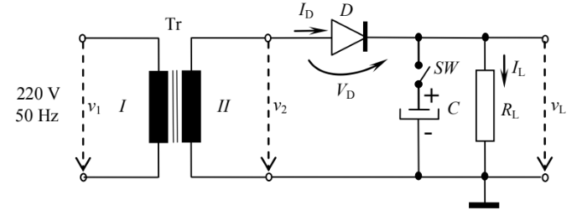

* ***Components***

1. *Tr – Step-Down Transformer*

* used to lower the voltage between the 2 circuits, while also increasing the current by the same factor
* N1 – nr. of coil turns from I
* N2 – nr. of coil turns from II ( < N1 )
* V1m – voltage amplitude of I
* V2m – voltage amplitude of II
* – transformation ratio

1. *D – Diode*

* constitutes the rectifier of the circuit
* allows current to pass only in one direction, the positive half of the input sinusoidal wave

1. *C – Capacitor*

* makes up the low-pass filter
* used to smoothen the pulsating DC waveform

1. *RL – Load Resistor*

* ***Values***
* RL = 5kΩ
* C – cases:

1. No capacitor
2. 1 capacitor – C = 22µF
3. 2 capacitors in parallel – C = 44µF
4. 3 capacitors in parallel – C = 66µF

* ***Formulas***
* ( no capacitor )
* , ( with capacitor )
* ***Experimental Procedure***
* make the circuit above
* using a multimeter ( VAC domain ), it is measured the voltage given by the transformer secondary -> amplitude ( A = V2m ) & time period ( T )
* For the 4 cases: SW open, SW closed(1C, 2C & 3C):
  + output waveform vL(t) is observed
  + measurements are took for the DC component of the output voltage VLDC and the ripple ∆vL
* ***Measurements – taken from screenshots of oscilloscope(lab 3)***
* **Case I – No C**
* **Case II – 1 C**
* **Case III – 2 C**
* **Case IV – 3 C**

|  |  |
| --- | --- |
| *CASE I* | *CASE II* |
| *CASE III* | ***CASE IV*** |

* ***Calculations***
* **Case I – No C**
* **Case II – 1 C**
* **Case III – 2 C**
* **Case IV – 3 C**
* ***Simulations***

|  |
| --- |
| ***CASE I*** |
| ***CASE II*** |
| ***CASE III*** |
| ***CASE IV*** |

* ***Tables***
* ***Experimental***

|  |  |  |  |
| --- | --- | --- | --- |
| ***CAPACITORS*** |  |  |  |
| 0 | 18.9 | - | 5.80 |
| 1 | 18.7 | 1.88 | 17.76 |
| 2 | 18.7 | 1.11 | 18.15 |
| 3 | 18.7 | 0.74 | 18.33 |

* ***Calculation***

|  |  |  |
| --- | --- | --- |
| ***CAPACITORS*** |  |  |
| 0 | - | 6.02 |
| 1 | 3.44 | 17.18 |
| 2 | 1.72 | 18.04 |
| 3 | 1.15 | 18.33 |

* ***Conclusion***

Following the experiments & calculations, we can conclude that with the increase in capacitors, the output DC voltage also increases and the ripple decreases, smoothening the DC waveform.